Duke of Edinburgh Award Wellbeing
Skills For Life

Contents Page
Week 1 – Understanding Mental Health
Week 2 – Healthy Coping Strategies
Week 3 – Understanding Adolescence/Sleep
Week 4 – Managing Your Emotions
Week 5 – Peer Mentoring
Week 6 – The Listening Role
Week 7 – The Role of The Good Listener
Week 8 – Your Wellbeing Skills Project
Week 9 – Researching Your Topic
Week 10 – Creating Your Resource
Week 11 – Presenting Your Resource
Week 12 – Reflections

Dear Parent or Guardian,

As part of their work towards the Duke of Edinburgh Bronze Award your child has opted to complete the “Wellbeing Skills for Life” course created by Teen Tips. This course is designed to encourage young people to develop ways to look after their own wellbeing and that of others; to develop good listening skills and to create a resource to support the wellbeing of others.

The material for the course is provided online and participants will have the opportunity to use online resources and group discussions to complete a workbook. We hope participants enjoy the resources and activities and enjoy the insights into human behaviour they gain. The course will run over approximately twelve weeks and will take thirteen hours to complete. There is no charge for this activity.

Teen Tips recommends that those following the activities keep alert to how to stay safe online. We are confident that the resources we recommend are age appropriate for those taking the Bronze Award, but we encourage those taking the course to focus only on those resources we provide or recommend. We recommend also that groups working together on the award in schools or other organisations are supervised by an adult representative of that organisation.

If you are happy for your child to complete this activity, please sign the consent slip below and return it to the leader of your child’s Duke of Edinburgh group.

Consent Slip
I (insert your name)_____________________________________________ consent to my child’s (insert child’s name)______________________________________ participation in the “Wellbeing Skills for Life” course offered by Teen Tips as part of their work towards the Duke of Edinburgh Bronze Award.

How to Use This Course

This course is structured into twelve units which each look at aspects of mental health and wellbeing for life.

You will need to complete each unit in turn to make the most of the course.

Each Unit should take about an hour to complete although the research and creation of your resource which begins in Unit Eight and continues through to Unit Eleven will need an extra hour. This means the total length of the course will be thirteen hours.

There will be several videos throughout the course. You can access this by clicking on the video link.

If you have any difficulties in completing the course, please talk to your Duke of Edinburgh course leader who will be able to contact Teen Tips for any necessary further advice.

WEEK 1
What is mental health?

Objectives - Our aim in Course Unit One is to identify what good mental health and wellbeing are and to explore what might have a detrimental effect on a person's mental health.

Firstly, watch ‘Mental Health Explained’:
https://vimeo.com/649870692/547a25134a

- In the four boxes below, note down what has made you choose to follow this course. We will refer to these goals when you reach the end to see whether you have met or exceeded them.

- In the box below, write out your understanding of good mental health in roughly 100 words.

- Discuss what you have written with one or more friends - ideally someone who has done the same exercise. Note down areas of common ground.

- Can you do a survey of six people in your age-group and ask them what they think might have a negative impact on their mental health and wellbeing. Then ask six people in the 20-40 year age group and six in the 40+ age group what they think affects the mental health of people your age.

PEER GROUP RESPONSES | 20–40-YEAR-OLD AGE GROUP RESPONSES | 40+ AGE GROUP RESPONSES

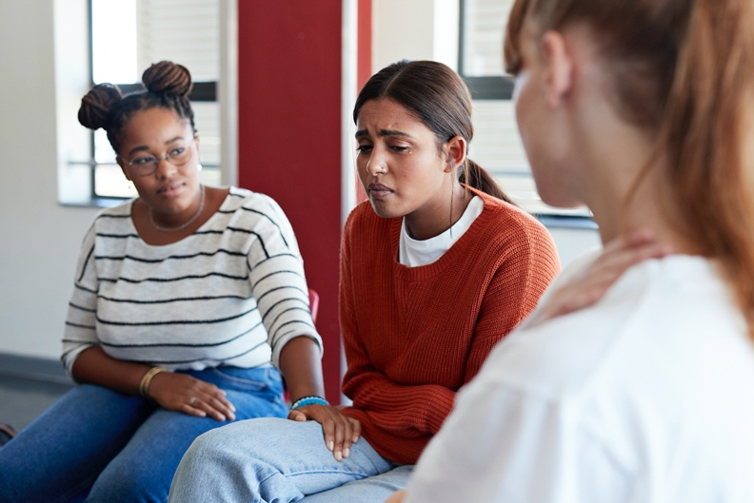

THE END OF WEEK 1

WEEK 2
Healthy Coping Strategies
In Unit One of this course, we looked at what might have a positive or negative effect on a person’s mental health and wellbeing. In this unit we are going to look at finding healthy coping strategies to deal with things that might challenge our wellbeing. We will establish what coping strategies are, and how to use them.

- Meet Alaya: she is 15 and a good hockey player. She's dyslexic but doing ok in school where she has a lot of friends. Recently her family (mum, dad, two brothers and a cat) have decided to move from Plymouth to Edinburgh because her mum has a new job.

- Create a mind map in the space below to show what worries Alaya might be having about the move. You could work with a partner on this activity if you like.

- It will be clear from the diagram you have just drawn that Alaya might have several worries. We are now going to look at some coping strategies which might help her to overcome them.

- Can you write down what you think “coping strategies” are in just eight words, in the boxes below?

Watch this ‘coping strategies video’ with Alicia Drummond: https://vimeo.com/649879124/8d3f091d19

- Was your eight-word definition, right? Change it if you think you can improve on what you wrote, in the box below.

- Can you explain in your own words how coping strategies work? Write your answer in the box below.

- Let's return to the case study about Alaya that we considered in Activity One of this unit. In the table below, the first column outlines some of the things Alaya might be worrying about. Could you suggest how she could change her thinking or what she could do to address her worries in the second column?

Alaya's worries | Alternative thoughts/actions
I won't know anyone
School will think I'm stupid
I'll miss my friends
I'll let my current team down
I'll never get on a new team
I might get bullied at school
I had tickets to see Ariana Grande in Plymouth in December
My dad might not get a new job

- Are there any other suggestions that a good friend, who is likely to miss Alaya, might make at this time? Write your ideas below.

- My own two coping strategies are:

10.This is how I feel when I use them:

THE END OF WEEK 2

WEEK 3

Understanding Adolescence/Sleep

Watch this ‘sleep’ video with Alicia Drummond: https://vimeo.com/649898602/aa7c908418

1.In the box below, note down what you think is a good definition of “Adolescence". You don't need to go into a lot of biological detail - try to keep to under 50 words.

You are likely to have written in the box that adolescence is a time between about 10 and 18 years old when a person's body develops into that of an adult. You are likely to have mentioned physical and hormonal changes and you may also have mentioned differing moods and behaviours.

2.Now have a look at the table of statements below. In the right-hand columns, tick whether you believe each statement is true or false.

 | Statement | True | False
1 | Adolescence is between the ages of 8 and 16 years old
2 | During adolescence we change the bonds we had with our parents to become fully independent
3 | Teenagers are programmed to test boundaries
4 | Adolescence is a time when the brain is "rewired"
5 | The rewiring process is not usually complete until a person reaches their mid-twenties
6 | Adolescence is usually between the ages of 8 and 20 years old
7 | Teenagers are very well motivated by reward - risk-taking can be a way to get rewards
8 | Immediate gratification is more appealing to the teenage brain than long-term plans
9 | The pre-frontal cortex - home of reasoning - is not well-connected to the rest of the teenage brain - instead, the emotional or limbic brain has the strongest influence
10 | Teenagers need less sleep than adults
11 | Teenagers naturally need to go to sleep later and wake up later than adults
12 | Adolescents often misread facial expressions
13 | Lack of sleep impairs judgement
14 | The brain rewires at night

- How did you get on with the true or false exercise above?

All the answers were true except for number’s 1 (adolescence can run into the early twenties) and 10 (adolescents need more sleep than adults). As you now know, sleep is incredibly important.

- Take a few moments to describe your sleep routine in the boxes below:

What time do you go to bed?
Do you read before you go to sleep? If you do, for how long?
Do you watch TV when you are in bed? If you do, for how long and does the TV go off?
Do you spend time on your phone before you go to sleep? If you do, what are you using it for?
Is your phone on silent at night?
Does your phone ever beep in the night? And what do you do if it does?
If you are a gamer, how long before you go to bed do you stop gaming - or do you even game in bed?
How many hours do you sleep each night?

- As a final activity for this unit, note down in the box below what a good sleep routine would be for you and then, try to put it into practice for at least once this week and see how you feel.

THE END OF WEEK 3

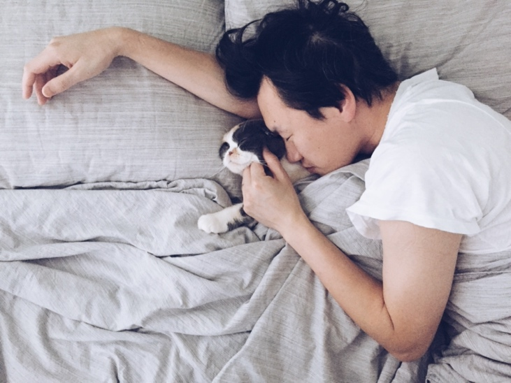

WEEK 4
Managing Your Emotions

Welcome to Unit 4 of the Wellbeing Skills for Life. We hope you were able to try your new sleep routine and that we find you bright-eyed and bushy tailed as a result!

This unit will focus on emotions and their management. We hope you find it interesting.

- Complete the wordsearch below. All the words you will find are to do with emotions - the feelings we have in response to what happens to and around us.
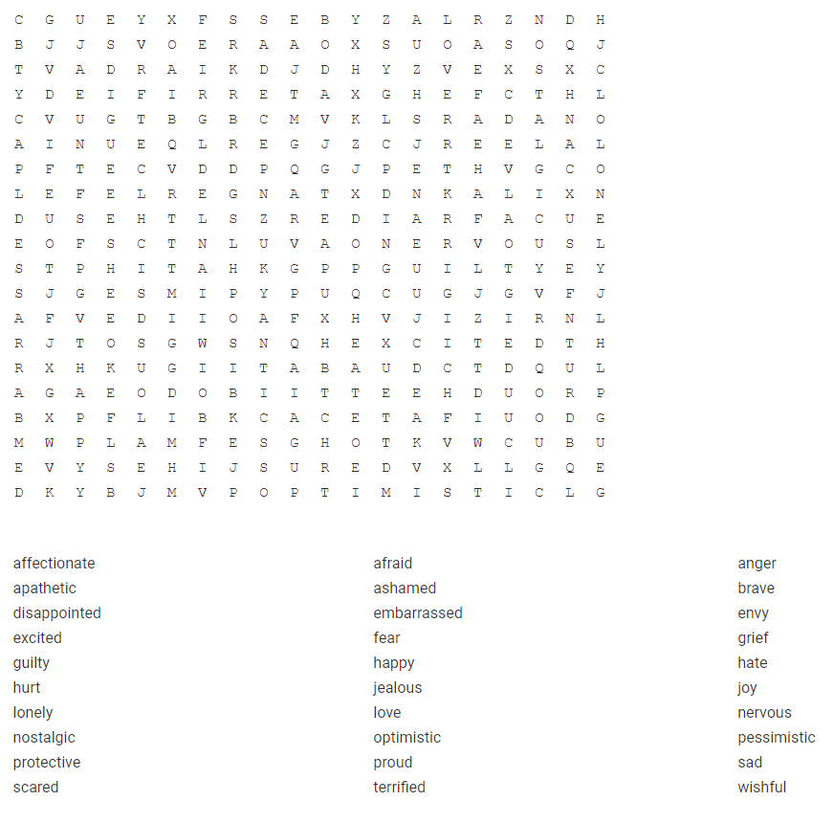
- What emotions are the speakers in the table below experiencing? When you've written your answers, highlight any positive emotions in green and any negative ones in blue.

Person | Emotions
Hassan:
"I've trained for four years, and I'll finally find out on Monday if I've been selected for Team GB under sixteens".
Karine:
"I shouldn't have stolen the money from mum, but I was angry and really needed more credit on my phone. I don't know what to do now'.
Alex:
"I just can't believe I got all 9s in my GCSEs. Mum and Ellen will be so proud, but I know my sister didn't get the grades she wanted last year".
Xavier:
'Mum! I can't find the dog. I left the back door open, and he got out'.

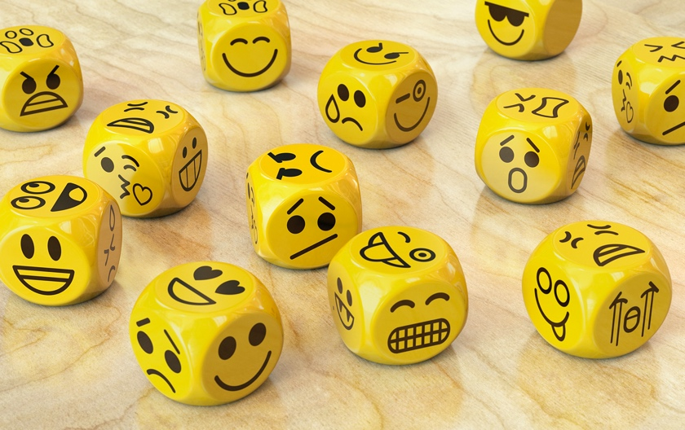

- Now we've identified some different emotions we're going to look at how we might recognise these in people.

Can you identify an image from the photos below where their facial expression best reflects the emotion described? Write your choice in the table below. Give the column letter followed by the row number. For example, person E3 has both hands on their head.
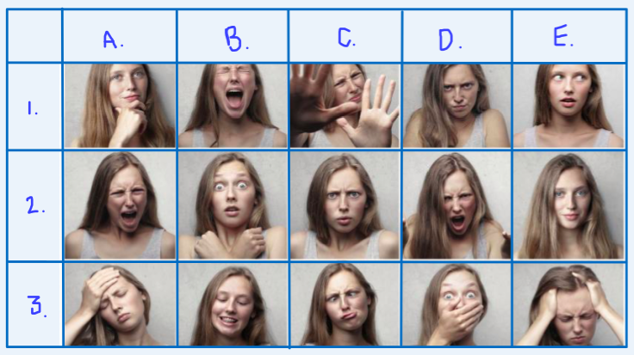
Emotion | My Choice | Partner's Choice
Afraid
Concerned
Embarrassed
Nervous
Happy
Jealous
Angry
Confused
Proud
Terrified

Now compare your choices with those of a partner. Did you agree in all instances? Our guess is that you didn't! (But very well done if you did).

- From what you have just watched, what is the best way to help others with their emotions? Write down your thoughts in the box below.

So, basically, we need to recognise that emotions exist, we all have them and very few of us have mastered them. We just need to recognise what is driving them and that all emotions have a purpose. E.g., anger can make us take action and guilt can make us apologise.

- Use the diary below to note down some of the things that you find rewarding, that you’re proud of or that you're grateful for over the course of the next week. This will help you to focus on good emotions and to notice that there is a lot of good in your world.

Day | … | Your Thoughts
Day 1. | What I enjoyed today
 | What I am proud of today
 | Something I am grateful for
Day 2. | What I enjoyed today
 | What I am proud of today
 | Something I am grateful for
Day 3. | What I enjoyed today
 | What I am proud of today
 | Something I am grateful for
Day 4. | What I enjoyed today
 | What I am proud of today
 | Something I am grateful for
Day 5. | What I enjoyed today
 | What I am proud of today
 | Something I am grateful for
Day 6. | What I enjoyed today
 | What I am proud of today
 | Something I am grateful for
Day 7. | What I enjoyed today
 | What I am proud of today
 | Something I am grateful for

THE END OF WEEK

WEEK 5
Peer Mentoring

Introduction
In Unit Four we recognised that emotions are not usually felt one at a time and that this usually means that when someone is not in a good place it can be difficult to pinpoint exactly why.
In this unit we are going to explore effective listening techniques to try to find ways to support those who are not feeling at their best.

- Consider what you might do in the following situation:

Shamina's best friend, Jenna, seems much quieter than usual. She's normally loud and chatty but over the course of the last week you have noticed she has been missing during break and lunchtimes at school and hasn't been joining in with social media activity.

Have a look at the table below which lists some possible things Shamina could do. In the left-hand boxes write what you think would happen next…

 | You could... | Possible outcome...
1 | ...ask friends if they know whether there is something bothering her
2 | ...take Jenna to one side and ask her if she's ok
3 | ...find different people to hang out with
4 | ...talk to her parents about it
5 | ...call Jenna over to sit with you and her other friends and ask her if she's ok
6 | ...talk to Jenna's sister about her

If you have a partner to work with, discuss your thoughts on the possible outcomes with them.
In most of the options above Shamina would be sharing her concerns about Jenna with other people. Although all are meant kindly, they involve other people which Jenna might not want, so the most advisable course of action in the first place would be Option 2. But what's the best way to do this?

- At this stage Jenna hasn't shared with Shamina that there is anything wrong. It might just be that she's busy with schoolwork or an out of school activity such as a show, or there might be something really bothering her. Now consider the statements below and select which one you think you would use to start the conversation you want to have:

- People have been saying you've not been around...
- Can we talk?
- Are you ok?
- I've not seen you properly for a bit, what have I done?
- I've been wondering what's up with you...
- Do you fancy a catch up?

Which of the six sentences above is likely to leave Jenna feeling most comfortable and which least comfortable?

If you wanted to talk to somebody about something which was either personal or upsetting, what would they need to do to make you feel comfortable enough to talk?

If you're worried about someone's safety, it’s important to find extra help. Ask the person you are listening to if they have a trusted adult in their life to talk to. Offer to go with them to talk to their trusted adult, but if they refuse to talk to an adult and you are still worried, it is okay for you to talk to an adult you trust.

THE END OF WEEK 5

WEEK 6
Peer Mentoring

Introduction

In the previous unit we explored the skills necessary to be a good listener and, in this unit, we will go on to develop your active listening skills and empathy to help others manage their mental health and wellbeing. Remember that you are not responsible for the wellbeing of others but you may be able to help them by listening.

- Spend five minutes reflecting and jot down some notes in the box below about the last time you needed to confide in someone...
- Did you approach them, or did they approach you?
- Did you know what was bothering you when you started to speak?
- Do you feel you picked the right person to listen?
- Were you embarrassed at wanting to talk?
- How did you feel about the responses your listener gave?
- Did you feel better after talking?

- What kind of a listener are you?

Complete the table below by ticking a ranking out of 5 for each statement where 1 is "strongly agree" and 5 is "strongly disagree". Whatever your answer profiles, this will make you aware of the kind of listener you are.

 |  | 1 | 2 | 3 | 4 | 5
A | I feel uncomfortable when people tell me what is on their mind.
B | I can usually tell if someone is worried.
C | I like to help people.
D | I try to solve people's problems.
E | People come to me to talk.
F | I think I give good advice.
G | People tend not to come to me for advice.
H | Other people can give better advice than I can.

- Now it's time to practise your listening skills. To do this you will need to work with a partner and one of you will be Person A and the other, possibly unsurprisingly, Person B.

Person A
You are worried because you have just found out that you will be moving to a new school in September after a move to a new city. Someone in another class at this school has told you the school has a bit of a history of bullying, and you're really scared but you don't want to talk about it with your parents as they have enough to think about with the move.

Person B

You are worried because you know it means a lot to your parents that you are in the local football team. Recently you have missed a couple of training sessions because your English teachers wanted you to go for extra exam practice after school. You are embarrassed that you have needed the extra support. Now your parents have found out that you haven't been selected to play in a match this weekend and are saying they will have words with the coach this evening...

- Take it in turns to be the listener and the person needing help and act out two role plays. After each role play, give feedback on how you felt the listener was?

- Were they able to develop the areas they felt could benefit from more work?

- Remember this exercise was to help you find out what kind of listener you are and to help you add to your skills.

- If you are feeling really confident, you could record your role plays and then listen back to them together.

THE END OF WEEK 6

WEEK 7
The Good Listener

Introduction

In the last two units we have explored the importance of listening skills and we have considered the positive impact good listening can have on a person whose wellbeing is not all it could be.

In this unit, we will look a little more closely at the role of the listener to ensure that they remain in good mental health as they support their companions.

- Let us consider the circumstances in which we may find ourselves the listener. Read the statements below; which ones are likely to be true for a person who has chosen to confide in you?

Number the statements below:

1.Likely to be true 2. Might be true 3. Unlikely to be true.

They would like you to keep what they share to yourself
They would like you to let all your friends know
They trust you
They don't feel they can deal with the issue alone
They have embellished (added to) the story
They are not telling you everything
They have made everything up
They feel afraid/embarrassed/upset

- Until a person tells us what is bothering them, we cannot help, other than be there for them. Once they tell us, things are different because we have background thoughts about different circumstances and useful knowledge that may help.

Look at the table below and draw lines to match up the problems on the left with the most likely solution on the right. You could use the "Draw" menu to do this if you are working online.

Problem | Probable solution
I have cut my finger | Collect my spare key from the neighbour
I have lost my purse | Iron it
My houseplants are wilting | Put on a sticking plaster
I have found a cyclist unconscious in the street | Apologise
I haven't done my homework | Cancel my credit cards
My school uniform is crumpled | Call an ambulance
I have locked myself out of the house | Give them some water
I have offended my friend | Confess to my teacher

It is likely that you found that activity quite easy because you have life experiences that will be stored in your mind which will help you deal with the issues. So will your friends, so when someone has a worry that they feel less able to deal with, it is perfectly possible that the listener will be less confident too. The next activity will help establish some ways to ensure our listening is safe.

- Very sadly, there are issues that we experience that are more serious than others. We are about to look at some more complex, invented situations. Before we start, please be reminded that if you find thinking about any of this material upsetting you can find help through the following:

Childline
https://www.childline.org.uk

NSPCC
https://www.nspcc.org.uk

Kooth.
https://www.kooth.com

Example One:
Al has just (1) dropped his lunch tray in the school dining room and (2) burst into tears when the others in the dining hall laughed. Later, you talk. He tells you that (3) he was hungry, (4) didn't have more money to replace his meal because his dad was asleep when he set off for school this morning and he didn't like to disturb him to ask for money. (5) His dad has been drinking rather heavily of late and (6) can be a bit angry, even violent with Al.

Which of the issues in Example One do you think are the most serious and why?

Imagine you have been friends with Al since you first started school and you are now both 14. How would YOU feel having heard what he has told you?

Reflection
It is likely that you have identified in the example above that Al is having some problems at home. His dad is clearly not well, and this is generating a potential physical threat to Al's safety, and it is possible that his nutritional needs are not being cared for. Yes, he was embarrassed that he dropped his tray but this will pass if you listen without judging him. The next step is to think how best to support him with the more serious issues. You are not a counsellor and not professionally qualified to help him so could you suggest that he talk to someone in the pastoral team at your school? Perhaps you could offer to go with him to talk to someone. And if he didn't feel he wanted to do that, maybe you could talk to someone in confidence about your worries?

Example Two
Jade, who has been your best friend for four years, shows you (1) a new phone that her new boyfriend gave her last night when he took her out for a meal and to (2) meet his friends. She is thrilled with it. You and Jade are 15 and, from what she has said, you think Jade's (3) boyfriend is in his early twenties. They have been going out for two weeks and you haven't met him. She has asked to confide in you because (4) he has asked her to go away with him for the weekend and (5) she doesn't think her parents would let her. (6) She'd like you to say she is coming for a sleepover at your house so that she has an excuse to go away.

Which of the numbered points in Example Two might cause you to worry? Write your answer in the box.

Reflection
There are a few issues here. Jade has been your best friend for some time, but you have not yet met her boyfriend - who seems to have given her an expensive gift and put pressure on her to go away very early in their relationship. And now she's asking you to lie to her parents (and yours). Quite simply, there are a few worries here. You care about Jade, but she seems not to realise she is in a risky situation with a guy who is a lot older than her. You should definitely not lie for her, but you should also talk seriously to her about what she is proposing to do. If she is determined to go ahead with her plan you must talk to a trusted adult.

THE END OF WEEK 7

WEEK 8
Your Wellbeing Skills Project

Introduction

In this Unit you will begin creating your own wellbeing resource. This will be presented at the end of Week 11. The project will add to your bank of wellbeing skills for life.

You could make a short film, a podcast, a blog, roleplay, or a PowerPoint/Prezi on one of the below topics:

- Understanding mental health
- Healthy coping strategies
- Understanding adolescence and sleep
- Managing your emotions
- Listening skills

You will be asked to present your resource to your pastoral lead. Keep your presentation to about five minutes.

- Choosing your project area

In the box below note down key areas of interest from this workbook. Think about what topics you would like to include in your project.

- Now, we need to select a wellbeing skills topic to work on for your project.
You have spent time reflecting on your own experience. Now choose which area best follows the four statements below.

Statement | Area
The area I think I have the balance of wellbeing skills best is...

The area where I would like to improve my wellbeing skills is...

The area where my friends would say they have the balance of wellbeing skills best is...
The area where I think our friendship group could build wellbeing skills is...

Could you decide to look at one of these areas for your project?

- If you are working with a group, we recommend that you discuss different wellbeing skill areas to work on for a few minutes before completing the box at the end of this activity. If you are working alone, have a think about yourself and your peers and what you think might best support your wellbeing skills

In the box below, replace the lines with your choice of words:

My Project Choice
I have decided to work on the area of _________ for my project. This is because______________________________________ .

THE END OF WEEK 8

WEEK 9
Researching Your Topic

Introduction
In Week 8 of this course, you chose a topic as a focus for the wellbeing skills resource you are going to create. In this unit we will look at how to research this topic in a little more depth so that you know how best to structure your resource.

- In this activity you are going to build a mind map around your chosen topic. Write your topic in the middle of the box below and then use the branches to show issues associated with your topic and to make suggestions as to what might help develop wellbeing skills to work through these issues.

Before you start, please remember that the internet is vast and not all the information you will be shown is going to be accurate.
Only use sites you trust and NEVER engage with strangers online.
The links below lead directly to sites we feel you might find useful, but you should be wary of choosing to follow pop up links that may not be controlled by the organisations we list below.
We recommend that you carry out your research using a computer on your school network or with the supervision of a responsible adult.
You can, of course, use a library to find books and articles, or look for podcasts to help your research.

- Useful starting points
You might choose to follow one of the links below to begin your research. You probably won't need all the links as you have a specific topic area to research. Try to find names of people who are specialists in working in the area you have chosen or examples of projects.

Sources of information are available as starting points. Try the following links:
These links are to the website of the charity, MIND:

https://www.mind.org.uk/information-support/tips-for-everyday-living/wellbeing/wellbeing/

https://www.mind.org.uk/media/8615/tips-to-improve-your-wellbeing-2020-easy-read.pdf

The National Health Service (NHS) produces valuable resources:

This link leads to a page on sleep:

https://www.nhs.uk/every-mind-matters/mental-health-issues/sleep/

Young Minds is a charity fighting for young people's mental health:

https://www.youngminds.org.uk/

Some Teen Tips Resources of things which are covered within this workbook:

https://club.teentips.co.uk/wp-content/uploads/2021/11/Healthy-coping-strategies--e1636557995942.png

https://club.teentips.co.uk/wp-content/uploads/2021/11/Mental-health-Tip-Sheet-Pupils-e1636558214725.png

https://club.teentips.co.uk/wp-content/uploads/2021/11/Tips-for-relaxing-e1636558328375.png

https://club.teentips.co.uk/wp-content/uploads/2021/11/1-e1636558591202.png

https://club.teentips.co.uk/wp-content/uploads/2021/11/2-e1636558633483.png

https://club.teentips.co.uk/wp-content/uploads/2021/11/Social-Anxiety-Tip-Sheet.pdf

https://club.teentips.co.uk/wp-content/uploads/2021/11/How-to-be-a-good-listener.png

- Now that you have spent some time looking at areas relating to your chosen research topic, it's time to make a few notes.

Complete column 2 in the table below by writing a brief phrase that follows on from the phrase in column 1. Then record a little more detail about your thinking in column 3. (It's ok if you prefer to write in detail).

1 | 2 | 3
I have chosen to work on...
My chosen area
is important because...
If this area is neglected...
Activities that help are...
Specialists in this area
of wellbeing are...

- The table you completed in Activity Three has allowed you to identify a clearer focus for your research and you will be able to use this as a basis when you present your resources to your group in Week 11.

Now use any remaining time from today's course time to flesh out your thoughts on what activity or activities might make for a good resource.

Use the box below for your notes. If you prefer to draw out your plans, please go ahead and just insert a photo of your finished drawing in the box.

THE END OF WEEK 9

WEEK 10
Creating Your Resource

Introduction

In Week 9 you successfully completed research into your chosen wellbeing skills area, and you are now ready to create a resource which will have a positive effect on the wellbeing of others.
The activities below are designed to help you plan and create your resource.

- Think about your lessons and activities at school. Could you make a few notes in the box below about what makes an activity enjoyable and what doesn't? Spend about five minutes on this.

- The Following kinds of activity can be good for our wellbeing. Number the following activities in order of which ones would help best with your chosen topic area. The most helpful ones being 1 and the least helpful 10.

- Physical activity
- Eating cake
- Drawing
- Noting down our gratitude’s
- Keeping a journal
- Cooking
- Eating fruit and vegetables
- Reading
- Meeting friends
- Computer gaming
- Watching TV
- Using social media
- Sleeping
- Sewing
- Crafting

- Complete the project plan below:

Who will benefit
from your resource?
What do you have to do to use the resource?
What period of time does the activity cover?
How do you know
your resource is effective?

- Now you are ready to create your project. Spend the next 45 minutes designing and creating your project.

You can use the box below to outline your resource or jot down notes.

THE END OF WEEK 10

WEEK 11
Presenting Your Resource

Introduction

This unit asks you to present the resource you have designed to help develop the wellbeing skills for life. Your resource will add to the collection of tools you have to improve your own and others wellbeing.

  - Spend the next 10 minutes finalising your presentation plan.

This might help you with your planning...

- What area of wellbeing skills have you chosen?
- Why did you pick this area?
- What helps?
- What is your activity?
- How do you complete the activity?
- What is the desired outcome?

When you and your Duke of Edinburgh leader are ready, you should now deliver your presentation. Good luck!

  - Get some positive feedback.

What good things did the people attending the presentation say about your resource?

Spend one minute getting feedback and one minute jotting it down in the box below.

THE END OF WEEK 11

WEEK 12
Reflections

Introduction
You have now completed this course and will have a good understanding of what skills and factors contribute to our wellbeing. You will have created a project which others could use to help them develop a better understanding of their own wellbeing.

In the first part of this unit, we will reflect on what you have learnt and, in the second part we will look at how you could use your skills to promote wellbeing in your school or social group.

  - Answer the following questions:

- Are there any of the wellbeing skills that are more difficult to develop? Why do you think that is?
- Are there any activities or resources that others devised which you think you would enjoy using?

- At the start of this course, you wrote down four sentences outlining why you had chosen to take part in The Wellbeing Skills for Life. Think about the progress you have made then, write a few notes to say whether you feel you have met or exceeded those goals and explain why.

If you feel you didn't meet a particular goal, can you note that in the box below and identify why?

- You have invested a good deal of time, thought, creativity and empathy in developing your knowledge of wellbeing skills for life - well done - and we hope you have found the experience rewarding.

As a final activity, spend 10 minutes thinking or discussing any ideas you have for raising the profile of wellbeing skills in your school or social group. You will be giving voluntary service to others.

Make some notes from your thoughts or discussion in the box below. In no more than 70 words, outline what you would like to do next in the box below.

Are there people who can help you get your ideas off the ground? Talk to adults at school or your social group.

We would love to hear about your successful adventures. As you have now completed your project your Duke of Edinburgh leader will be able to forward to us any feedback and we will share it with the Duke of Edinburgh organisation.

You have successfully completed the Wellbeing skills for Life programme – CONGRATULATIONS! Please email DofE@teentips.co.uk with your name for an official certificate.

